**Eventbrite Training**

**Date**: 15 May 2023 **Location**: MS Teams Meeting

**Attendees:**

1) Sheila Ann Cabanayan

2) Amrit Panti Sunar

3) Vishwa Kumari Tushar Kumar

4) Srivardhan Muthyala

5) Soheb Ahmad Khan

**Agenda:**

Discussion about the Eventbrite training which is needed to be taken by all the PM Guild Members.

**Minutes:**

**Meeting opened:**

* The meeting started at 9:45 pm
* The meeting commenced with Miss Sheila, the President of PM Guild talking about the template to be followed for the minutes of meeting.
* Followed by Mr. Sunar Learning about Event Calendar that is to be followed for the rest of the semester.
* Following this Discussions about Eventbrite is done where we can create the tickets and bookings of events. Also, the credentials are also shared to login into this website.

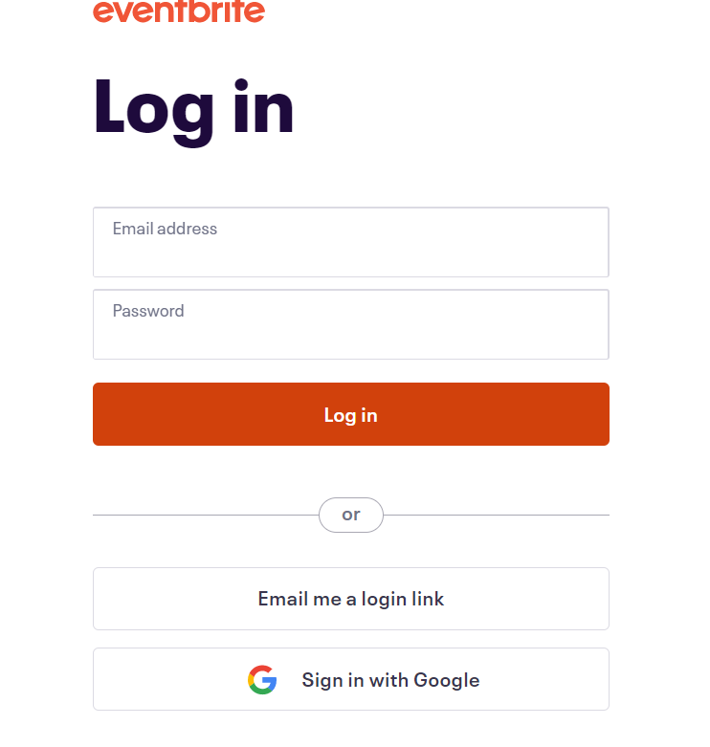

* To Optimize the length of URLs to the QR Code we can use Bitly.

* To Generate the QR Code We Use QR Monkey, and the login Credentials are same for Everyone. URL that is optimized using Bitly is shared to QR Monkey.

* We can use the specifications available and create our QR Code
* Following this the poster and flairs design must be done using Canva for better quality.
* The discussions regarding the E mail Remainders for events were also done.
* **Virtual events:**  Ms team links for the virtual events are supposed to be created by the HR Team for virtual events to avoid ambiguity.
* The Meeting is finally concluded by Miss Sheila after delivering the aforementioned information to the marketing team
* **Ending Time:** 10:40 PM EST